**SVM vs. Random Forest for image segmentation :**

**(1) For SVM we just change in our above code . we change random forest into SVM :**

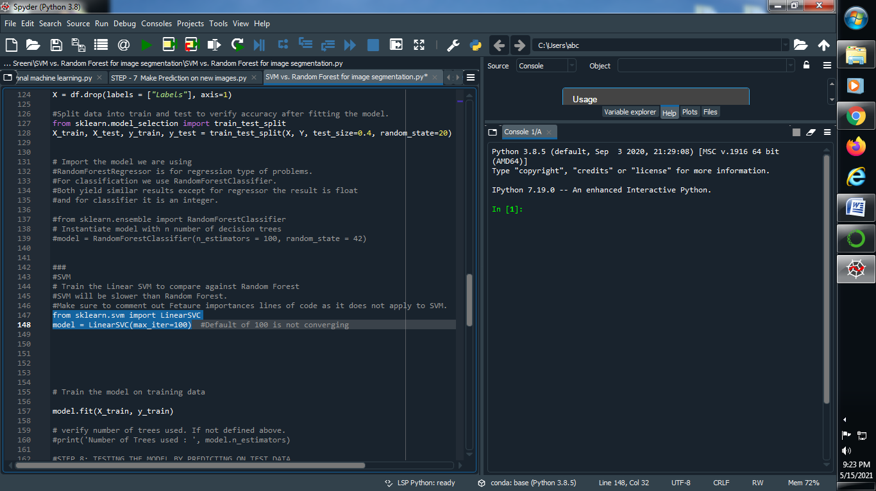

**Note : SVM takes a lot of time to perform this . so we can say Random forest is more efficient than SVM (Support Vector Machine)**

**Output :**

**→ Train image : → Label image :**

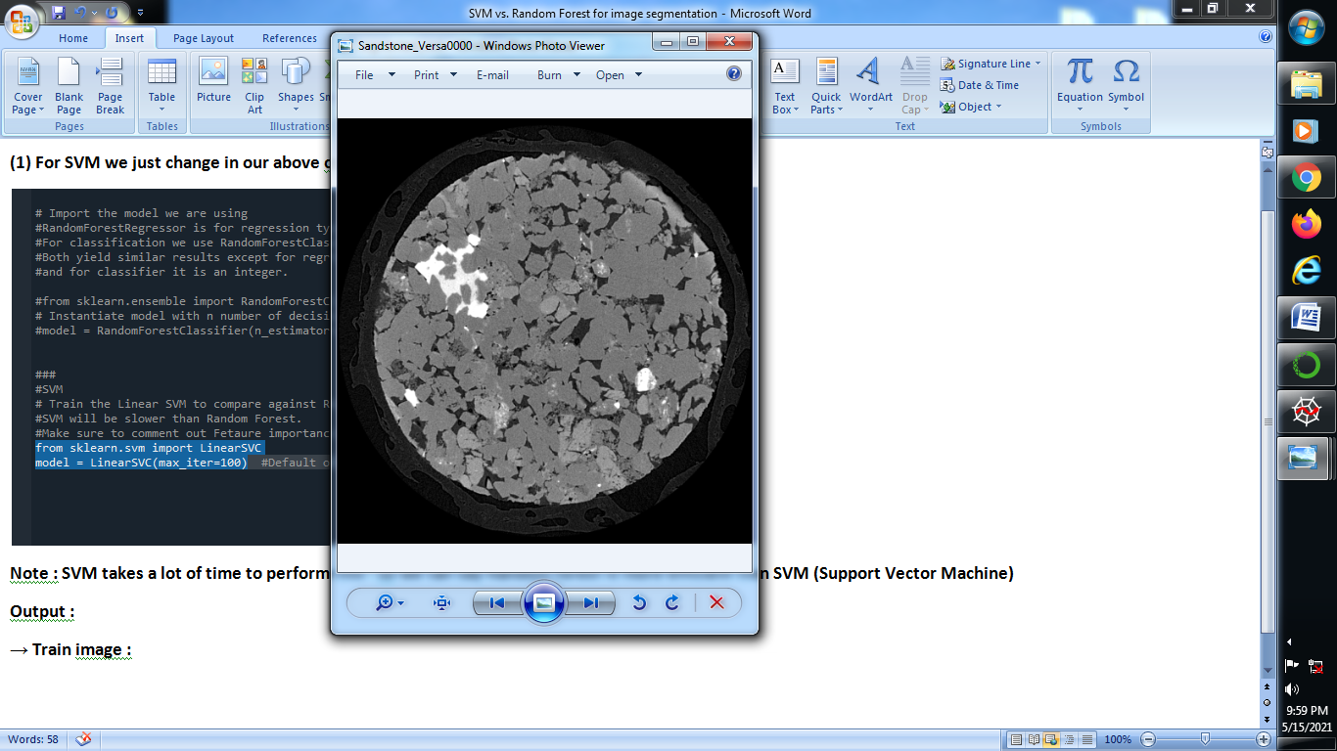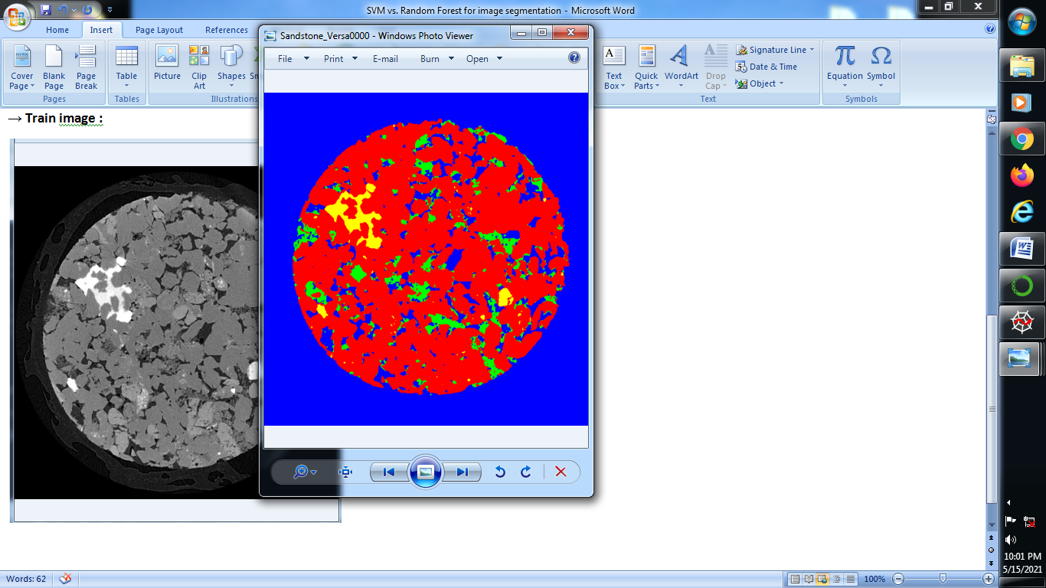

**→ SEGMENTED IMAGE :**

